

Black History Month
The Dr. Edna B. McKenzie Branch of ASALH
presents
Panel Discussion: Black Female Legacies in the Arts

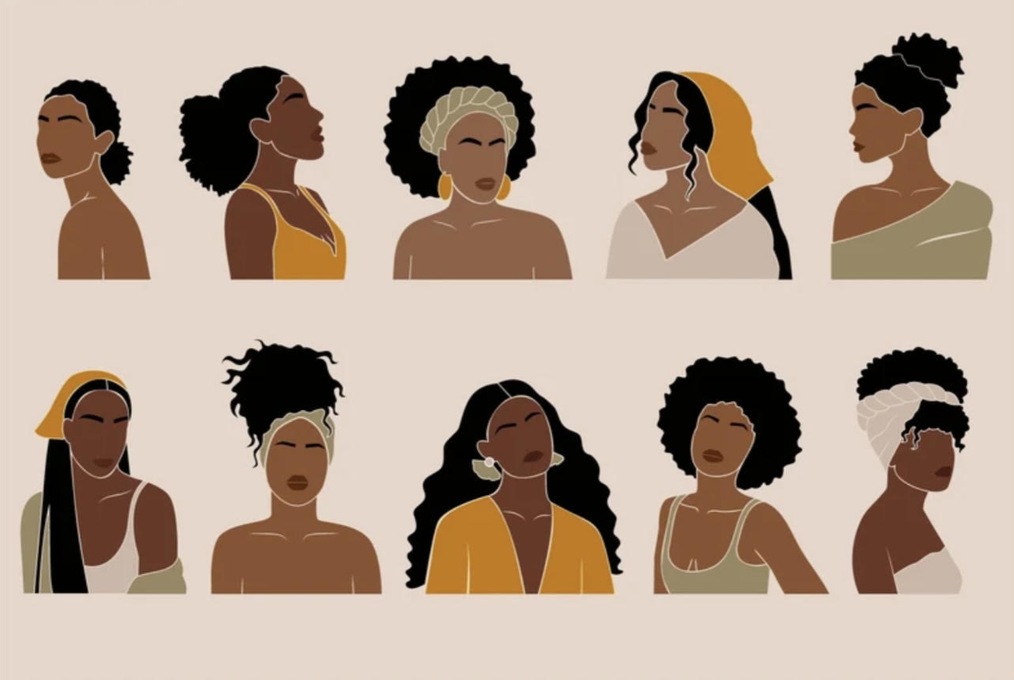

Facilitated by
Dr. Mildred Mickle

Featuring
Lynn b.
Janet Watkins
Adele Vassar

Saturday, February 10, 2024
11:30 AM EST – 1:00 PM EST

Virtual Meeting via ZOOM
Register in advance for this meeting:
https://us02web.zoom.us/meeting/register/tZYvcu6uqTgtH9TK7LY3CdDoKl-uYv3p3VU3

